Developer documentation

* **How to obtain the source code.**

We got some codes from the CSDN. Our team has completed the rest of the functions.

* **The layout of your directory structure.** What do the various directories (folders) contain, and where to find source files, tests, documentation, data files, etc.

Directory structure:

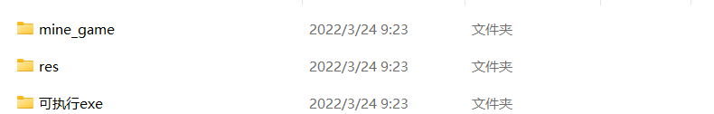

It includes mine_game,res and exe files.

The folder of mine_game cotain the files of debug and the source file.The folder of res contains the pictures that the source file use.The folder of exe contains the file of exe.

* **How to build the software.**

We developed this game based on windows. Here is our framework.

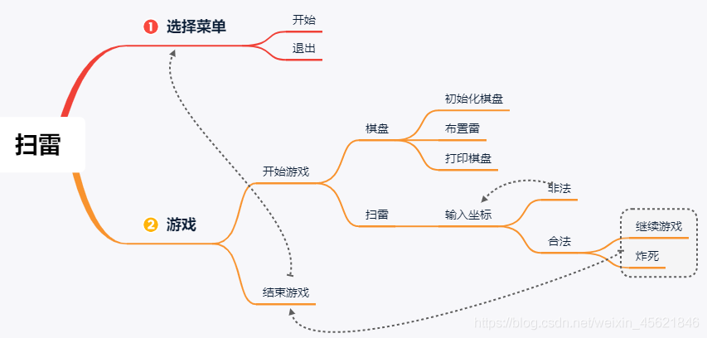

* **How to test the software.**

During the development period, we have been tested repeatedly at each stage. After the development, we launched the internal test version, which has been tried by many people. Finally, the system test was completed.

* **How to add new tests.**

When we launch a new version, we will go through repeated tests, and the test documents will be released to the internal users in the form of internal test. This is the main way we test.

* **How to build a release of the software.** Describe any tasks that are not automated. For example, should a developer update a version number (in code and documentation) prior to invoking the build system? Are there any sanity checks a developer should perform after building a release?

When we update the version, we will call the previous version. When the previous version is compatible, we will iteratively upgrade the version.